3GPP TS 29.508 V15.2.0 (2018-12)
Technical Specification
3rd Generation Partnership Project;
Technical Specification Group Core Network and Terminals;
5G System; Session Management Event Exposure Service;
Stage 3
(Release 15)


The present document has been developed within the 3rd Generation Partnership Project (3GPP TM) and may be further elaborated for the purposes of 3GPP.
The present document has not been subject to any approval process by the 3GPP Organizational Partners and shall not be implemented.
This Specification is provided for future development work within 3GPP only. The Organizational Partners accept no liability for any use of this Specification.
Specifications and Reports for implementation of the 3GPP TM system should be obtained via the 3GPP Organizational Partners' Publications Offices.

Keywords

3GPP
Postal address

3GPP support office address
650 Route des Lucioles - Sophia Antipolis
Valbonne - FRANCE
Tel.: +33 4 92 94 42 00 Fax: +33 4 93 65 47 16
Internet
http://www.3gpp.org
Copyright Notification
No part may be reproduced except as authorized by written permission.
The copyright and the foregoing restriction extend to reproduction in all media.

© 2018, 3GPP Organizational Partners (ARIB, ATIS, CCSA, ETSI, TSDSI, TTA, TTC).
All rights reserved.

UMTS™ is a Trade Mark of ETSI registered for the benefit of its members
3GPP™ is a Trade Mark of ETSI registered for the benefit of its Members and of the 3GPP Organizational Partners
LTE™ is a Trade Mark of ETSI registered for the benefit of its Members and of the 3GPP Organizational Partners
GSM® and the GSM logo are registered and owned by the GSM Association
Contents
Foreword 5
1 Scope 6
2 References 6
3 Definitions and abbreviations 7
3.1 Definitions 7
3.2 Abbreviations 7
4 Session Management Event Exposure Service 7
4.1 Service Description 7
4.1.1 Overview 7
4.1.2 Service Architecture 8
4.1.3 Network Functions 9
4.1.3.1 Session Management Function (SMF) 9
4.1.3.2 NF Service Consumers 9
4.2 Service Operations 9
4.2.1 Introduction 9
4.2.2 Nsmf_EventExposure_Notify Service Operation 9
4.2.2.1 General 9
4.2.2.2 Notification about subscribed events 10
4.2.3 Nsmf_EventExposure_Subscribe Service Operation 11
4.2.3.1 General 11
4.2.3.2 Creating a new subscription 12
4.2.3.3 Modifying an existing subscription 13
4.2.4 Nsmf_EventExposure_UnSubscribe Service Operation 14
4.2.4.1 General 14
4.2.4.2 Unsubscription from event notifications 14
5 Nsmf_EventExposure API 14
5.1 Introduction 14
5.2 Usage of HTTP 15
5.2.1 General 15
5.2.2 HTTP standard headers 15
5.2.2.1 General 15
5.2.2.2 Content type 15
5.2.3 HTTP custom headers 15
5.3 Resources 16
5.3.1 Resource Structure 16
5.3.2 Resource: SMF Notification Subscriptions 16
5.3.2.1 Description 16
5.3.2.2 Resource definition 16
5.3.2.3 Resource Standard Methods 17
5.3.2.3.1 POST 17
5.3.2.4 Resource Custom Operations 17
5.3.3 Resource: Individual SMF Notification Subscription 17
5.3.3.1 Description 17
5.3.3.2 Resource definition 17
5.3.3.3 Resource Standard Methods 17
5.3.3.3.1 GET 17
5.3.3.3.2 PUT 18
5.3.3.3.3 DELETE 18
5.3.3.4 Resource Custom Operations 19
5.4 Custom Operations without associated resources 19
5.5 Notifications 19
5.5.1 General 19
5.5.2 Event Notification 19
5.5.2.1 Description 19
5.5.2.2 Target URI 19
5.5.2.3 Standard Methods 20
5.5.2.3.1 POST 20
5.6 Data Model 20
5.6.1 General 20
5.6.2 Structured data types 21
5.6.2.1 Introduction 21
5.6.2.2 Type NsmfEventExposure 22
5.6.2.3 Type NsmfEventExposureNotification 23
5.6.2.4 Type EventSubscription 23
5.6.2.5 Type EventNotification 24
5.6.3 Simple data types and enumerations 25
5.6.3.1 Introduction 25
5.6.3.2 Simple data types 25
5.6.3.3 Enumeration: SmfEvent 25
5.6.3.4 Enumeration: NotificationMethod 25
5.7 Error handling 25
5.7.1 General 25
5.7.2 Protocol Errors 26
5.7.3 Application Errors 26
5.8 Feature negotiation 26
5.9 Security 26
Annex A (normative): OpenAPI specification 27
A.1 General 27
A.2 Nsmf_EventExposure API 27
Annex B (informative): Change history 33

Foreword
This Technical Specification has been produced by the 3rd Generation Partnership Project (3GPP).
The contents of the present document are subject to continuing work within the TSG and may change following formal TSG approval. Should the TSG modify the contents of the present document, it will be re-released by the TSG with an identifying change of release date and an increase in version number as follows:
Version x.y.z
where:
x the first digit:
1 presented to TSG for information;
2 presented to TSG for approval;
3 or greater indicates TSG approved document under change control.
y the second digit is incremented for all changes of substance, i.e. technical enhancements, corrections, updates, etc.
z the third digit is incremented when editorial only changes have been incorporated in the document.

1 Scope
The present specification provides the stage 3 definition of the Session Management Event Exposure Service (Nsmf_EventExposure) of the 5G System.
The stage 2 definition and procedures of the Session Management Event Exposure Service are contained in 3GPP TS 23.502 [3] and 3GPP TS 23.503 [6]. The 5G System Architecture is defined in 3GPP TS 23.501 [2].
Stage 3 call flows for policy and charging control use cases are provided in 3GPP TS 29.513 [7].
The Technical Realization of the Service Based Architecture and the Principles and Guidelines for Services Definition of the 5G System are specified in 3GPP TS 29.500 [4] and 3GPP TS 29.501 [5].
The Session Management Event Exposure Service is provided by the Session Management Function (SMF). This service exposes events related to PDU Sessions observed at the SMF.

2 References
The following documents contain provisions which, through reference in this text, constitute provisions of the present document.
- References are either specific (identified by date of publication, edition number, version number, etc.) or non-specific.
- For a specific reference, subsequent revisions do not apply.
- For a non-specific reference, the latest version applies. In the case of a reference to a 3GPP document (including a GSM document), a non-specific reference implicitly refers to the latest version of that document in the same Release as the present document.
[1] 3GPP TR 21.905: "Vocabulary for 3GPP Specifications".
[2] 3GPP TS 23.501: "System Architecture for the 5G System; Stage 2".
[3] 3GPP TS 23.502: "Procedures for the 5G System; Stage 2".
[4] 3GPP TS 29.500: "5G System; Technical Realization of Service Based Architecture; Stage 3".
[5] 3GPP TS 29.501: "5G System; Principles and Guidelines for Services Definition; Stage 3".
[6] 3GPP TS 23.503: "Policy and Charging Control Framework for the 5G System; Stage 2".
[7] 3GPP TS 29.513: "5G System; Policy and Charging Control signalling flows and QoS parameter mapping; Stage 3".
[8] IETF RFC 7540: "Hypertext Transfer Protocol Version 2 (HTTP/2)".
[9] IETF RFC 8259: "The JavaScript Object Notation (JSON) Data Interchange Format".
[10] OpenAPI, "OpenAPI 3.0.0 Specification", https://github.com/OAI/OpenAPI-Specification/blob/master/versions/3.0.0.md.
[11] 3GPP TS 29.571: "5G System; Common Data Types for Service Based Interfaces Stage 3".
[12] 3GPP TS 29.510: "5G System; Network Function Repository Services; Stage 3".
[13] 3GPP TS 29.518: "5G System; Access and Mobility Management Services; Stage 3".
[14] 3GPP TS 29.512: "5G System; Session Management Policy Control Service; Stage 3".
[15] 3GPP TS 33.501: "Security architecture and procedures for 5G system".
[16] IETF RFC 6749: "The OAuth 2.0 Authorization Framework".
[18] IETF RFC 7807: "Problem Details for HTTP APIs".

3 Definitions and abbreviations

3.1 Definitions
For the purposes of the present document, the terms and definitions given in 3GPP TR 21.905 [1] and the following apply. A term defined in the present document takes precedence over the definition of the same term, if any, in 3GPP TR 21.905 [1].

3.2 Abbreviations
For the purposes of the present document, the abbreviations given in 3GPP TR 21.905 [1] and the following apply. An abbreviation defined in the present document takes precedence over the definition of the same abbreviation, if any, in 3GPP TR 21.905 [1].
AF Application Function
AMBR Aggregate Maximum Bit Rate
AMF Access and Mobility Management Function
API Application Programming Interface
DNAI DN Access Identifier
DNN Data Network Name
GUAMI Globally Unique AMF Identifier
HTTP Hypertext Transfer Protocol
JSON JavaScript Object Notation
NEF Network Exposure Function
NF Network Function
NRF Network Repository Function
SMF Session Management Function
SUPI Subscription Permanent Identifier
PCF Policy Control Function
PRA Presence Reporting Area
UPF User Plane Function

4 Session Management Event Exposure Service

4.1 Service Description

4.1.1 Overview
The Session Management Event Exposure Service, as defined in 3GPP TS 23.502 [3] and 3GPP TS 23.503 [6], is provided by the Session Management Function (SMF).
This service:
- allows consumer NFs to subscribe and unsubscribe for events on a PDU session; and
- notifies consumer NFs with a corresponding subscription about observed events on the PDU session.
The types of observed events include:
- UP path change (e,g, addition and/or removal of PDU session anchor);
- access type change;
- PLMN change;
- PDU session release; and
- UE IP address/prefix change.

4.1.2 Service Architecture
The 5G System Architecture is defined in 3GPP TS 23.501 [2]. The Policy and Charging related 5G architecture is also described in 3GPP TS 29.513 [7].
The Session Management Event Exposure Service (Nsmf_EventExposure) is part of the Nsmf service-based interface exhibited by the Session Management Function (SMF),
Known consumer of the Nsmf_EventExposure_Notify service are:
- Network Exposure Function (NEF)
- Access and Mobility Management Function (AMF).
- Application Function (AF)
The PCF accesses the Session Management Event Exposure Service at the SMF via the N7 Reference point.
NOTE: The PCF can implicitly subscribe on behalf of the AF and NEF to the UP_PATH_CH event by including the information on AF subscription within the PCC rule.
The AMF accesses the Session Management Event Exposure Service at the SMF via the N11 Reference point.
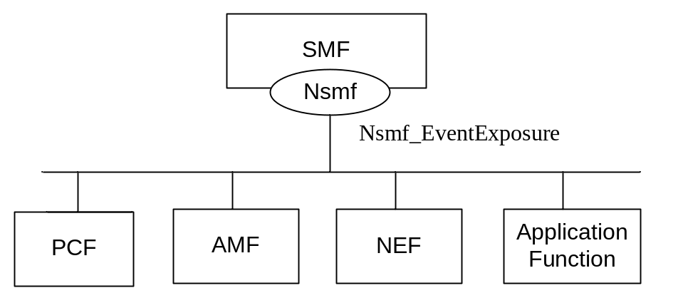
Figure 4.1.2-1: Reference Architecture for the Nsmf_EventExposure_Notify Service; SBI representation
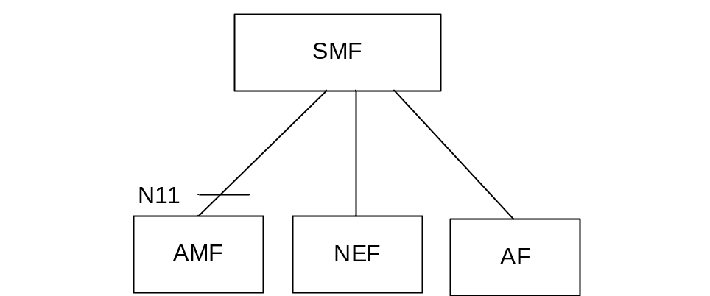
Figure 4.1.2-2: Reference Architecture for the Nsmf_EventExposure_Notify Service: reference point representation

4.1.3 Network Functions

4.1.3.1 Session Management Function (SMF)
The Session Management function (SMF) provides:
- Session Management e.g. Session establishment, modification and release;
- UE IP address allocation & management;
- Selection and control of UP function;
- Termination of interfaces towards Policy control functions; and
- Control part of policy enforcement and QoS.

4.1.3.2 NF Service Consumers
The Network Exposure Function (NEF);
- provides a means to securely expose the services and capabilities provided by 3GPP network functions for e.g. 3rd parties or internal exposure.
The Access and Mobility Management function (AMF) provides:
- Registration management;
- Connection management;
- Reachability management; and
- Mobility Management.
The Application Function (AF)
- interacts with the 3GPP Core Network to provide services.

4.2 Service Operations

4.2.1 Introduction
Table 4.2.1-1: Operations of the Nsmf_EventExposure_Notify Service
Service operation name | Description | Initiated by
Notify | Report UE PDU session related event(s) to the NF service consumer which has subscribed to the event report service. | SMF
Subscribe | This service operation is used by an NF service consumer to subscribe for event notifications on a specified PDU session, or for all PDU Sessions of one UE, a group of UE(s) or any UE, or to modify a subscription. | NF service consumer
UnSubscribe | This service operation is used by an NF service consumer to unsubscribe from event notifications. | NF service consumer

4.2.2 Nsmf_EventExposure_Notify Service Operation

4.2.2.1 General
The Nsmf_EventExposure_Notify service operation enables notification to NF service consumers that the previously subscribed event on the related PDU session occurred.
The following procedure using the Nsmf_EventExposure_Notify service operation is supported:
- notification about subscribed events.

4.2.2.2 Notification about subscribed events
Figure 4.2.2.2-1 illustrates the notification about subscribed events.
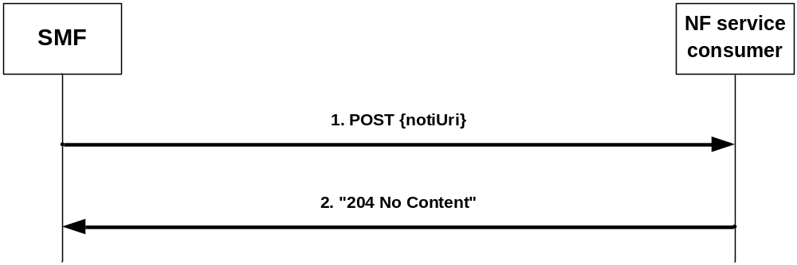
Figure 4.2.2.2-1: Notification about subscribed events
If the SMF observes PDU Session related event(s) for which an NF service consumer has subscribed to, the SMF shall send an HTTP POST request with "{notifUri}" as previously provided by the NF service consumer within the corresponding subscription as URI and NsmfEventExposureNotification data structure as request body that shall include:
- Notification correlation ID provided by the NF service consumer during the subscription, or as provided by the PCF for implicit subscription of UP path change as defined in subclause 4.2.6.2.6.2 of 3GPP TS 29.512 [14], as "notifId" attribute; and
- information about the observed event(s) within the "eventNotifs" attribute that shall contain for each observed event an "EventNotification" data structure that shall include:
1. the Event Trigger as "event" attribute;
2. for a UP path change notification:
a) type of notification ("EARLY" or "LATE") as "dnaiChgType" attribute;
b) source DNAI and target DNAI as "sourceDnai" attribute and "targetDnai" attribute if DNAI is changed, respectively; and
c) if the PDU Session type is IP, for the source DNAI IP address/prefix of the UE as "sourceUeIpv4Addr" attribute or "sourceUeIpv6Prefix" attribute; and
d) if the PDU Session type is IP, for the target DNAI IP address/prefix of the UE as "targetUeIpv4Addr" attribute or "targetUeIpv6Prefix" attribute;
e) for the source DNAI, N6 traffic routing information related to the UE as "sourceTraRouting" attribute;
f) for the target DNAI, N6 traffic routing information related to the UE as "targetTraRouting" attribute; and
g) if the PDU Session type is Ethernet, the MAC address of the UE in the "ueMac" attribute;
NOTE 1: UP path change notification, i.e. DNAI change notification and/or N6 traffic routing information change notification, can be the result of an implicit subscription of the PCF on behalf of the NEF/AF as part of setting PCC rule(s) via the Npcf_SMPolicyControl service (see subclause 4.2.6.2.6.2 of 3GPP TS 29.512 [14]).
NOTE 2: If the DNAI is not changed while the N6 traffic routing information change, the source DNAI and target DNAI are not provided.
3. for a UE IP address change:
a) added new UE IP address or prefix as "adIpv4Addr" attribute or "adIpv6Prefix" attribute, respectively; and/or
b) released UE IP address or prefix as "reIpv4Addr" attribute or "reIpv6Prefix" attribute, respectively;
4. for an access type change:
a) new access type as "accType" attribute;
5. for a PLMN Change:
a) new PLMN as "plmnId" attribute;
6. for a PDU Session Release:
a) ID of the released PDU session as "pduSeId" attribute;
7. the time at which the event was observed encoded as "timeStamp" attribute;
8. the SUPI as the "supi" attribute if the subscription applies to a group of UE(s) or any UE; and
9. if available, the GPSI as the "gpsi" attribute if the subscription applies to a group of UE(s) or any UE.
Upon the reception of the HTTP POST request with "{notifUri}" as URI and an NsmfEventExposureNotification data structure as request body, the NF shall send an "204 No Content" HTTP response for a succesfull processing.
If the NF service consumer is not able to handle the Notification but knows by implementation specific means that another service consumer is able to handle the notification, it shall reply with an HTTP "307 temporary redirect" error response pointing to the new NF service consumer URI. If the NF service consumer is not able to handle the Notification but another unknown service consumer could possibly handle the notification, it shall reply with an HTTP "404 Not found" error response.
NOTE 3: An AMF as service consumer can change.
If the SMF receives a "307 temporary redirect" response, the SMF shall use this URL as Notification URL in subsequent communication and shall resend the failed Notification to that URL.
If the SMF becomes aware that a new NF service consumer is requiring notifications (e.g. via the "404 Not found" response, or via Namf_Communication service AMFStatusChange Notifications, see 3GPP TS 29.518 [13], or via link level failures or via the Nnrf_NFDiscovery Service (using the service name and GUAMI obtained during the creation of the subscription) to query the other AMFs within the AMF set) specified in 3GPP TS 29.510 [12]), and the SMF knows alternate or backup IPv4 or IPv6 Addess(es) where to send Notifications (e.g. via "altNotifIpv4Addrs" or "altNotifIpv6Addrs" attributes received when the subscription was created), the SMF shall exchange the authority part of the Notification URL with one of those addresses and shall use that URL in subsequent communication. If the SMF received a "404 Not found" response, the SMF should resend the failed notification to that URL.

4.2.3 Nsmf_EventExposure_Subscribe Service Operation

4.2.3.1 General
This service operation is used by an NF service consumer to subscribe for event notifications on a specified PDU Session, or for all PDU Sessions of one UE, group of UE(s) or any UE, or to modify an existing subscription. The following are the types of events for which a subscription can be made:
- UP path change;
- PDU Session release;
- Change of Access Type;
- PLMN change; and
- UE IP address change.
The following procedures using the Nsmf_EventExposure_Subscribe service operation are supported:
- creating a new subscription;
- modifying an existing subscription.

4.2.3.2 Creating a new subscription
Figure 4.2.3.2-1 illustrates the creation of a subscription.
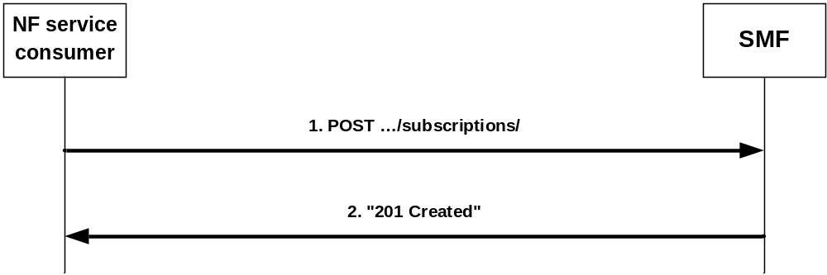
Figure 4.2.3.2-1: Creation of a subscription
To subscribe to event notifications, the NF service consumer shall send an HTTP POST request with: "{apiRoot}/nsmf-event-exposure/v1/subscriptions/" as Resource URI and the NsmfEventExposure data structure as request body that shall include:
- if the subscription applies to events related to a single PDU session, the PDU Session ID of that PDU session as "pduSeId" attribute;
- if the subscription applies to events not related to a single PDU session, identification of UEs to which the subscription applies via:
a) identification of a single UE by SUPI as "supi" attribute;
b) identification of a group of UE(s) via a "groupId" attribute; or
c) identification of any UE using a specific DNN via the "dnn" attribute;
NOTE: The identification of any UE does not apply for local breakout roaming scenarios where the SMF is located in the VPLMN and the NF service consumer is located in the HPLMN.
- an URI where to receive the requested notifications as "notifURI" attribute;
- a Notification Correlation Identifier assigned by the NF service consumer for the requested notifications as "notifId" attribute; and
- if the NF service consumer is an AMF, the GUAMI encoded as "guami" attribute:
- a description of the subscribed events as "eventSubs" attribute that for each event shall include:
a) an event identifier as "event" attribute; and
b) for event UP path change, whether the subscription is for early, late, or early and late notifications of UP path reconfiguration in the "dnaiChType" attribute;
The NsmfEventExposure data structure as request body may also include:
- Alternate or backup IPv4 Addess(es) where to send Notifications encoded as " altNotifIpv4Addrs" attribute;
- Alternate or backup IPv6 Addess(es) where to send Notifications encoded as " altNotifIpv6Addrs" attribute;
- if the NF service consumer is an AMF, the name of a service produced by the AMF that expects to receive the notification about subscribed events encoded as "serviceName" attribute;
- Immediate reporting flag as "ImmeRep" attribute;
- event notification method (periodic, one time, on event detection) as "notifMethod" attribute;
- Maximum Number of Reports as "maxReportNbr" attribute;
- Monitoring Duration as "expiry" attribute; and/or
- Repetition Period for periodic reporting as "repPeriod" attribute.
Upon the reception of an HTTP POST request with: "{apiRoot}/nsmf-event-exposure/v1/subscriptions/" as Resource URI and NsmfEventExposure data structure as request body, the SMF shall:
- create a new subscription;
- assign a subscription correlation ID;
- select an expiry time that is equal or less than a possible expiry time in the request;
- store the subscription;
- send a HTTP "201 Created" response with NsmfEventExposure data structure as response body and a Location header field containing the URI of the created individual subscription resource, i.e. {apiRoot}/nsmf-event-exposure/v1/subscriptions/{subId}; and
- if the "ImmeRep" attribute is included and set to true in the request, the SMF shall report the curret available value(s) for the subscribed event(s) as defined in subclause 4.2.3.1.
If the SMF received an GUAMI, the SMF may subscribe to GUAMI changes using the AMFStatusChange service operation of the Namf_Communication service specified in 3GPP TS 29.518 [13], and it may use the Nnrf_NFDiscovery Service specified in 3GPP TS 29.510 [12] (using the obtained GUAMI and possibly service name) to query the other AMFs within the AMF set.

4.2.3.3 Modifying an existing subscription
Figure 4.2.3.3-1 illustrates the modification of an existing subscription.
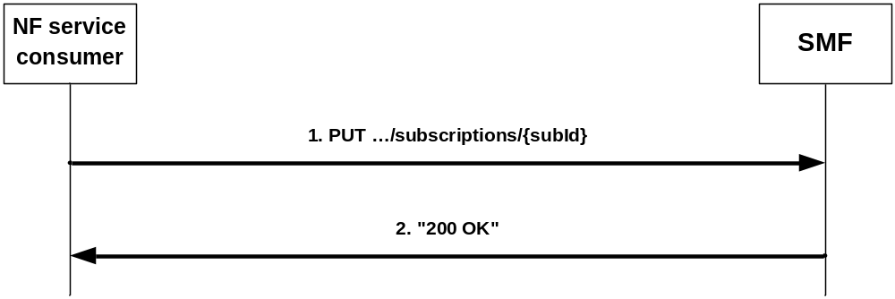
Figure 4.2.3.3-1: Modification of an existing subscription
To modify an existing subscription to event notifications, the NF service consumer shall send an HTTP PUT request with: "{apiRoot}/nsmf-event-exposure/v1/subscriptions/subId}" as Resource URI, where "{subId}" is the subscription correlation ID of the existing subscription, and NsmfEventExposure data structure as request body as described in subclause 4.2.3.2.
NOTE 1: An alternate NF service consumer than the one that requested the generation of the subscription resource can send the PUT. For instance, an AMF as service consumer can change.
NOTE 2: The "notifURI" attribute within the NsmfEventExposure data structure can be modified to request that subsequent notifications are sent to a new NF service consumer.
Upon the reception of an HTTP PUT request with: "{apiRoot}/nsmf-event-exposure/v1/subscriptions/{subId}" as Resource URI and NsmfEventExposure data structure as request body, the SMF shall:
- store the subscription; and
- send a HTTP "200 OK" response with NsmfEventExposure data structure as response body.

4.2.4 Nsmf_EventExposure_UnSubscribe Service Operation

4.2.4.1 General
This service operation is used by an NF service consumer to unsubscribe from event notifications.
The following procedure using the Nsmf_EventExposure_UnSubscribe service operation is supported:
- unsubscription from event notifications.

4.2.4.2 Unsubscription from event notifications
Figure 4.2.4.2-1 illustrates the unsubscription from event notifications.
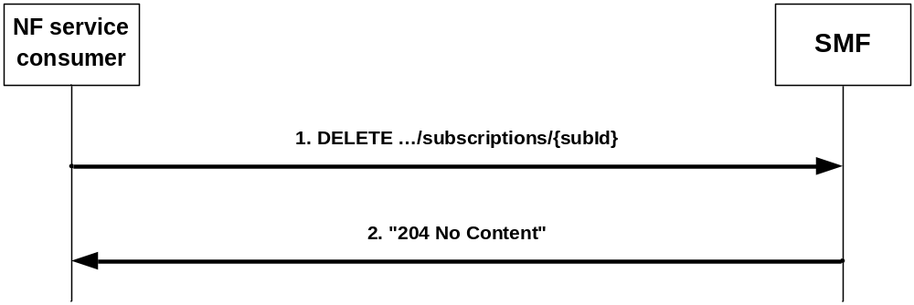
Figure 4.2.4.2-1: Unsubscription from event notifications
To unsubscribe from event notifications, the NF service consumer shall send an HTTP DELETE request with: "{apiRoot}/nsmf-eventexposure/v1/subscriptions/{subId}" as Resource URI, where "{subId}" is the subscription correlation ID of the existing subscription that is to be deleted.
Upon the reception of the HTTP DELETE request with: "{apiRoot}/nsmf-eventexposure/v1/subscriptions/{subId}" as Resource URI, the SMF shall:
- remove the corresponding subscription; and
- send an HTTP "204 No Content" response.

5 Nsmf_EventExposure API

5.1 Introduction
The Session Management Event Exposure Service shall use the Nsmf_EventExposure API.
The request URI used in HTTP request from the NF service consumer towards the SMF shall have the structure defined in subclause 4.4.1 of 3GPP TS 29.501 [5], i.e.:
{apiRoot}/{apiName}/{apiVersion}/{apiSpecificResourceUriPart}
with the following components:
- The {apiRoot} shall be set as described in 3GPP TS 29.501 [5].
- The {apiName} shall be "nsmf-event-exposure".
- The {apiVersion} shall be "v1".
- The {apiSpecificResourceUriPart} shall be set as described in subclause 5.3.

5.2 Usage of HTTP

5.2.1 General
HTTP/2, IETF RFC 7540 [8], shall be used as specified in clause 5 of 3GPP TS 29.500 [4].
HTTP/2 shall be transported as specified in subclause 5.3 of 3GPP TS 29.500 [4].
The OpenAPI [10] specification of HTTP messages and content bodies for the Nsmf_EventExposure is contained in Annex A.

5.2.2 HTTP standard headers

5.2.2.1 General
See subclause 5.2.2 of 3GPP TS 29.500 [4] for the usage of HTTP standard headers.

5.2.2.2 Content type
JSON, IETF RFC 8259 [9], shall be used as content type of the HTTP bodies specified in the present specification as specified in subclause 5.4 of 3GPP TS 29.500 [4]. The use of the JSON format shall be signalled by the content type "application/json".
"Problem Details" JSON object shall be used to indicate additional details of the error in a HTTP response body and shall be signalled by the content type "application/problem+json", as defined in IETF RFC 7807 [18].

5.2.3 HTTP custom headers
The mandatory HTTP custom header fields specified in subclause 5.2.3.2 of 3GPP TS 29.500 [4] shall be applicable.

5.3 Resources

5.3.1 Resource Structure
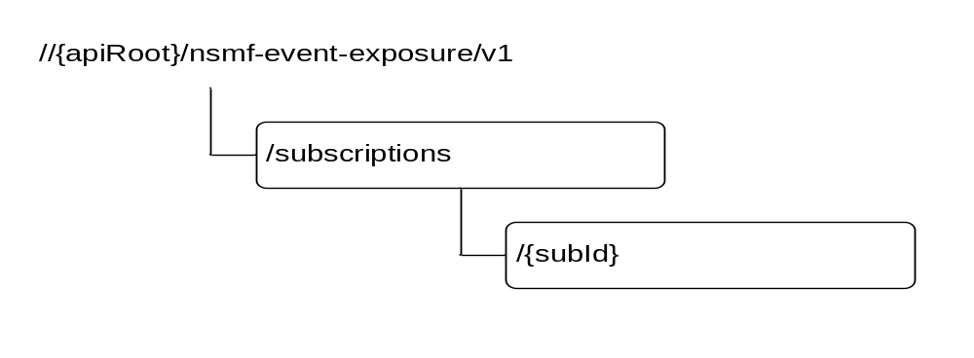
Figure 5.3.1-1: Resource URI structure of the Nsmf_EventExposure API
Table 5.3.1-1 provides an overview of the resources and applicable HTTP methods.
Table 5.3.1-1: Resources and methods overview
Resource name | Resource URI | HTTP method or custom operation | Description
SMF Notification Subscriptions | //{apiRoot}/  nsmf-event-exposure/  v1/  subscriptions | POST | Create a new Individual SMF Notification Subscription resource.
Individual SMF Notification Subscription | //{apiRoot}/  nsmf-event-exposure/  v1/  subscriptions/  {subId} | GET | Read an Individual SMF Notification Subscription resource.
Individual SMF Notification Subscription |  | PUT | Modify an existing Individual SMF Notification Subscription resource.
Individual SMF Notification Subscription |  | DELETE | Delete an Individual SMF Notification Subscription resource and cancel the related subscription.

5.3.2 Resource: SMF Notification Subscriptions

5.3.2.1 Description
The SMF Notification Subscriptions resource represents all subscriptions to the SMF event exposure service at a given SMF.

5.3.2.2 Resource definition
Resource URI: {apiRoot}/nsmf-event-exposure/v1/subscriptions/
This resource shall support the resource URI variables defined in table 5.3.2.2-1.
Table 5.3.2.2-1: Resource URI variables for this resource
Name | Definition
apiRoot | See subclause 5.1

5.3.2.3 Resource Standard Methods

5.3.2.3.1 POST
This method shall support the URI query parameters specified in table 5.3.2.3.1-1.
Table 5.3.2.3.1-1: URI query parameters supported by the POST method on this resource
Name | Data type | P | Cardinality | Description
n/a

This method shall support the request data structures specified in table 5.3.2.3.1-2 and the response data structures and response codes specified in table 5.3.2.3.1-3.
Table 5.3.2.3.1-2: Data structures supported by the POST Request Body on this resource
Data type | P | Cardinality | Description
NsmfEventExposure | M | 1 | Create a new Individual SMF Notification Subscription resource.

Table 5.3.2.3.1-3: Data structures supported by the POST Response Body on this resource
Data type | P | Cardinality | Response codes | Description
Nsmf_EventExposure | M | 1 | 201 Created | The creation of an Individual SMF Notification Subscription resource is confirmed and a representation of that resource is returned.
NOTE: The mandatory HTTP error status codes for the POST method listed in Table 5.2.7.1-1 of 3GPP TS 29.500 [4] also apply.

5.3.2.4 Resource Custom Operations
None.

5.3.3 Resource: Individual SMF Notification Subscription

5.3.3.1 Description
The SMF Notification Subscriptions resource represents a single subscription to the SMF event exposure service.

5.3.3.2 Resource definition
Resource URI: {apiRoot}/nsmf-event-exposure/v1/subscriptions/{subId}
This resource shall support the resource URI variables defined in table 5.3.3.2-1.
Table 5.3.3.2-1: Resource URI variables for this resource
Name | Definition
apiRoot | See subclause 5.1
subId | String identifying a subscription to the SMF event exposure service formatted as defined for the SubId type in table 5.6.3.2-1.

5.3.3.3 Resource Standard Methods

5.3.3.3.1 GET
This method shall support the URI query parameters specified in table 5.3.3.3.1-1.
Table 5.3.3.3.1-1: URI query parameters supported by the GET method on this resource
Name | Data type | P | Cardinality | Description
n/a

This method shall support the request data structures specified in table 5.3.3.3.1-2 and the response data structures and response codes specified in table 5.3.3.3.1-3.
Table 5.3.3.3.1-2: Data structures supported by the GET Request Body on this resource
Data type | P | Cardinality | Description
n/a

Table 5.3.3.3.1-3: Data structures supported by the GET Response Body on this resource
Data type | P | Cardinality | Response codes | Description
NsmfEventExposure | M | 1 | 200 OK | A representation of the SMF Notification Subscription matching the eventSubId is returned.
NOTE: The mandatory HTTP error status codes for the GET method listed in Table 5.2.7.1-1 of 3GPP TS 29.500 [4] also apply.

5.3.3.3.2 PUT
This method shall support the URI query parameters specified in table 5.3.3.3.2-1.
Table 5.3.3.3.2-1: URI query parameters supported by the PUT method on this resource
Name | Data type | P | Cardinality | Description
n/a

This method shall support the request data structures specified in table 5.3.3.3.2-2 and the response data structures and response codes specified in table 5.3.3.3.2-3.
Table 5.3.3.3.2-2: Data structures supported by the PUT Request Body on this resource
Data type | P | Cardinality | Description
NsmfEventExposure | M | 1 | Modify the existing Individual SMF Notification Subscription resource matching the eventSubId according to the representation in the Nsmf_EventExposure

Table 5.3.3.3.2-3: Data structures supported by the PUT Response Body on this resource
Data type | P | Cardinality | Response codes | Description
NsmfEventExposure | M | 1 | 200 OK | Successful case: The Individual SMF Notification Subscription resource matching the eventSubId was modified and a representation is returned.
n/a |  |  | 204 No Content | Successful case: The Individual SMF Notification Subscription resource matching the eventSubId was modified.
NOTE: The mandatory HTTP error status codes for the PUT method listed in Table 5.2.7.1-1 of 3GPP TS 29.500 [4] also apply.

5.3.3.3.3 DELETE
This method shall support the URI query parameters specified in table 5.3.3.3.3-1.
Table 5.3.3.3.3-1: URI query parameters supported by the DELETE method on this resource
Name | Data type | P | Cardinality | Description
n/a

This method shall support the request data structures specified in table 5.3.3.3.3-2 and the response data structures and response codes specified in table 5.3.3.3.3-3.
Table 5.3.3.3.3-2: Data structures supported by the DELETE Request Body on this resource
Data type | P | Cardinality | Description
n/a

Table 5.3.3.3.3-3: Data structures supported by the DELETE Response Body on this resource
Data type | P | Cardinality | Response codes | Description
n/a |  |  | 204 No Content | Successful case: The Individual SMF Notification Subscription resource matching the subId was deleted.
NOTE: The manadatory HTTP error status code for the DELETE method listed in Table 5.2.7.1-1 of 3GPP TS 29.500 [4] also apply.

5.3.3.4 Resource Custom Operations
None.

5.4 Custom Operations without associated resources
None.

5.5 Notifications

5.5.1 General
Notifications shall comply to subclause 6.2 of 3GPP TS 29.500 [4] and subclause 4.6.2.3 of 3GPP TS 29.501 [5].

5.5.2 Event Notification

5.5.2.1 Description
The Event Notification is used by the SMF to report one or several observed Events to a NF service consumer that has subscribed to such Notifications via the Individual SMF Notification Subscription Resource.

5.5.2.2 Target URI
The Notification URI "{notifUri}" shall be used with the resource URI variables defined in table 5.5.2.2-1.
Table 5.5.2.2-1: Resource URI variables for this resource
Name | Definition
notifUri | String formatted as URI with the Notification Uri as assigned within the Individual SMF Notification Subscription Resource and described within the Nsmf_EventExposure type (see table 5.6.2.2-1).

5.5.2.3 Standard Methods

5.5.2.3.1 POST
This method shall support the URI query parameters specified in table 5.5.2.3.1-1.
Table 5.5.2.3.1-1: URI query parameters supported by the POST method on this resource
Name | Data type | P | Cardinality | Description
n/a

This method shall support the request data structures specified in table 5.5.2.3.1-2 and the response data structures and response codes specified in table 5.5.2.3.1-3.
Table 5.5.2.3.1-2: Data structures supported by the POST Request Body on this resource
Data type | P | Cardinality | Description
NsmfEventExposureNotification | M | 1 | Provides Information about observed events

Table 5.5.2.3.1-3: Data structures supported by the POST Response Body on this resource
Data type | P | Cardinality | Response codes | Description
n/a |  |  | 204 No Content | The receipt of the Notification is acknowledged.
n/a |  |  | 307 temporary redirect | The NF service consumer shall generate a Location header field containing a URI pointing to another NF service consumer to which the notification should be send.
ProblemDetails | M | 1 | 404 Not Found | The NF service consumer can use this response when the notification can be sent to another host.
NOTE: The mandatory HTTP error status codes for the POST method listed in Table 5.2.7.1-1 of 3GPP TS 29.500 [4] also apply.

5.6 Data Model

5.6.1 General
This subclause specifies the application data model supported by the API.
Table 5.6.1-1 specifies the data types defined for the Nsmf_EventExposure service based interface protocol.
Table 5.6.1-1: Nsmf_EventExposure specific Data Types
Data type | Section defined | Description | Applicability
EventNotification | 5.6.2.5 | Describes notifications about a single event that occurred.
EventSubscription | 5.6.2.4 | Represents the subscription to a single event
NotificationMethod | 5.6.3.4 | Represents the notification methods that can be subscribed
NsmfEventExposure | 5.6.2.2 | Represents an Individual SMF Notification Subscription resource
NsmfEventExposureNotification | 5.6.2.3 | Describes Notifications about events that occurred.
SmfEvent | 5.6.3.3 | Represents the types of events that can be subscribed
SubId | 5.6.3.2 | Identifies an Individual SMF Notification Subscription.

Table 5.6.1-2 specifies data types re-used by the Nsmf_EventExposure service based interface protocol from other specifications, including a reference to their respective specifications and when needed, a short description of their use within the Nsmf_EventExposure service based interface.
Table 5.6.1-2: Nsmf_EventExposure re-used Data Types
Data type | Reference | Comments | Applicability
AccessType | 3GPP TS 29.571 [11]
DateTime | 3GPP TS 29.571 [11]
Dnai | 3GPP TS 29.571 [11]
DnaiChangeType | 3GPP TS 29.571 [11] | Describes the types of DNAI change.
Dnn | 3GPP TS 29.571 [11]
DurationSec | 3GPP TS 29.571 [11]
Gpsi | 3GPP TS 29.571 [11]
GroupId | 3GPP TS 29.571 [11]
Guami | 3GPP TS 29.571 [11] | Globally Unique AMF Identifier
Ipv4Addr | 3GPP TS 29.571 [11]
Ipv6Addr | 3GPP TS 29.571 [11]
Ipv6Prefix | 3GPP TS 29.571 [11]
MacAddr48 | 3GPP TS 29.571 [11] | MAC Address.
PduSessionId | 3GPP TS 29.571 [11]
PlmnId | 3GPP TS 29.571 [11]
ProblemDetails | 3GPP TS 29.571 [11]
RouteToLocation | 3GPP TS 29.571 [11] | A traffic route to/from an DNAI
Supi | 3GPP TS 29.571 [11]
SupportedFeatures | 3GPP TS 29.571 [11] | Used to negotiate the applicability of the optional features defined in table 5.8-1.
Uinteger | 3GPP TS 29.571 [11]
Uri | 3GPP TS 29.571 [11]

5.6.2 Structured data types

5.6.2.1 Introduction
This subclause defines the structures to be used in resource representations.

5.6.2.2 Type NsmfEventExposure
Table 5.6.2.2-1: Definition of type NsmfEventExposure
Attribute name | Data type | P | Cardinality | Description | Applicability
supi | Supi | C | 0..1 | Subscription Permanent Identifier (NOTE)
gpsi | Gpsi | C | 0..1 | Generic Public Subscription Identifier (NOTE)
anyUeInd | boolean | C | 0..1 | This IE shall be present if the event subscription is applicable to any UE. Default value "FALSE" is used, if not present (NOTE)
groupId | GroupId | C | 0..1 | Identifies a group of UEs. (NOTE)
pduSeId | PduSessionId | C | 0..1 | PDU session ID (NOTE)
subId | SubId | C | 0..1 | Subscription ID.  This parameter shall be supplied by the SMF in HTTP responses that include an object of Nsmf_EventExposure type.
notifId | string | M | 1 | Notification Correlation ID assigned by the NF service consumer.
notifUri | Uri | M | 1 | Identifies the recipient of Notifications sent by the SMF.
altNotifIpv4Addrs | array(Ipv4Addr) | O | 1..N | Alternate or backup IPv4 Addess(es) where to send Notifications.
altNotifIpv6Addrs | array(Ipv6Addr) | O | 1..N | Alternate or backup IPv6 Addess(es) where to send Notifications.
eventSubs | array(EventSubscription) | M | 1..N | Subscribed events
ImmeRep | boolean | O | 0..1 | It is included and set to true if the immediate reporting of the current status of the subscribed event, if available is required.
notifMethod | NotificationMethod | O | 0..1 | If "notifMethod" is not supplied, the default value "ON_EVENT_DETECTION" applies.
maxReportNbr | Uinteger | O | 0..1 | If omitted, there is no limit.
expiry | DateTime | C | 0..1 | This attribute indicates the expiry time of the subscription, after which the SMF shall not send any event notifications and the subscription becomes invalid. It may be included in an event subscription request and may be included in an event subscription response based on operator policies. If an expiry time was included in the request, then the expiry time returned in the response should be less than or equal to that value. If the expiry time is not included in the response, the NF Service Consumer shall not associate an expiry time for the subscription.
repPeriod | DurationSec | C | 0..1 | Is supplied for notification Method "periodic".
guami | Guami | C | 0..1 | The Globally Unique AMF Identifier (GUAMI) shall be provided by an AMF as service consumer.
serviceName | string | O | 0..1 | If the NF service consumer is an AMF, it should provide the name of a service produced by the AMF that makes use of the notification about subscribed events.
supportedFeatures | SupportedFeatures | C | 0..1 | List of Supported features used as described in subclause 5.8.  This parameter shall be supplied by NF service consumer and SMF in the POST request that request the creation of an SMF Notification Subscriptions resource and the related reply, respectively.
NOTE: One of the PDU session of a single UE (pduSeId, and gpsi/supi), or a group of UEs (groupId), or anyUeInd set to TRUE shall be included.

5.6.2.3 Type NsmfEventExposureNotification
Table 5.6.2.3-1: Definition of type NsmfEventExposureNotification
Attribute name | Data type | P | Cardinality | Description | Applicability
notifId | string | M | 1 | Notification correlation ID used to identify the subscription which the notification is corresponding to. It shall be set to the same value as the “notifId" attribute of NsmfEventExposure data type or the value of "notifiCorreId" within the UpPathChgEvent data type defined in 3GPP TS 29.512 [14].
eventNotifs | array(EventNotification) | M | 1..N | Notifications about Individual Events

5.6.2.4 Type EventSubscription
Table 5.6.2.4-1: Definition of type EventSubscription
Attribute name | Data type | P | Cardinality | Description | Applicability
event | SmfEvent | M | 1 | Subscribed events
dnaiChType | DnaiChangeType | C | 0..1 | For event UP path change, whether the subscription is for early, late, or early and late DNAI change notification shall be supplied.

5.6.2.5 Type EventNotification
Table 5.6.2.5-1: Definition of type EventNotification
Attribute name | Data type | P | Cardinality | Description | Applicability
event | SmfEvent | M | 1 | Event that is notified.
timeStamp | DateTime | M | 1 | Time at which the event is observed.
supi | Supi | C | 0..1 | Subscription Permanent Identifier. It is included when the subscription applies to a group of UE(s) or any UE.
gpsi | Gpsi | C | 0..1 | Identifies a GPSI. It shall contain an MSISDN. It is included when it is available and the subscription applies to a group of UE(s) or any UE.
sourceDnai | Dnai | C | 0..1 | Source DN Access Identifier. Shall be included for event "UP_PATH_CH" if the DNAI changed (NOTE).
targetDnai | Dnai | C | 0..1 | Target DN Access Identifier. Shall be included for event "UP_PATH_CH" if the DNAI changed (NOTE).
dnaiChgType | DnaiChangeType | C | 0..1 | DNAI Change Type. Shall be included for event "UP_PATH_CH".
sourceUeIpv4Addr | Ipv4Addr | O | 0..1 | The IPv4 Address of the served UE for the source DNAI. May be included for event "UP_PATH_CH".
sourceUeIpv6Prefix | Ipv6Prefix | O | 0..1 | The Ipv6 Address Prefix of the served UE for the source DNAI. May be included for event "UP_PATH_CH".
targetUeIpv4Addr | Ipv4Addr | O | 0..1 | The IPv4 Address of the served UE for the target DNAI. May be included for event "UP_PATH_CH".
targetUeIpv6Prefix | Ipv6Prefix | O | 0..1 | The Ipv6 Address Prefix of the served UE for the target DNAI. May be included for event "UP_PATH_CH".
sourceTraRouting | RouteToLocation | C | 0..1 | N6 traffic routing information for the source DNAI. Shall be included for event "UP_PATH_CH".
targetTraRouting | RouteToLocation | C | 0..1 | N6 traffic routing information for the target DNAI. Shall be included for event "UP_PATH_CH".
ueMac | MacAddr48 | O | 0..1 | UE MAC address. May be included for event "UP_PATH_CH".
adIpv4Addr | Ipv4Addr | O | 0..1 | Added IPv4 Address(es). May be included for event "UE_IP_CH".
adIpv6Prefix | Ipv6Prefix | O | 0..1 | Added Ipv6 Address Prefix(es). May be included for event "UE_IP_CH".
reIpv4Addr | Ipv4Addr | O | 0..1 | Removed IPv4 Address(es). May be included for event "UE_IP_CH".
reIpv6Prefix | Ipv6Prefix | O | 0..1 | Removed Ipv6 Address Prefix(es). May be included for event "UE_IP_CH".
plmnId | PlmnId | C | 0..1 | New PLMN ID. Shall be included for event "PLMN_CH".
accType | AccessType | C | 0..1 | PDU session ID. Shall be included for event "AC_TY_CH".
pduSeId | PduSessionId | C | 0..1 | PDU session ID. Shall be included for event "PDU_SES_REL".
NOTE: If the DNAI is not changed while the N6 traffic routing information is changed, the "sourceDnai" attribute and "targetDnai" attribute shall not be provided.

5.6.3 Simple data types and enumerations

5.6.3.1 Introduction
This subclause defines simple data types and enumerations that can be referenced from data structures defined in the previous subclauses.

5.6.3.2 Simple data types
The simple data types defined in table 5.6.3.2-1 shall be supported.
Table 5.6.3.2-1: Simple data types
Type Name | Type Definition | Description | Applicability
SubId | string | Identifies an Individual SMF Notification Subscription. To enable that the value is used as part of a URI, the string shall only contain characters allowed according to the "lower-with-hyphen" naming convention defined in 3GPP TS 29.501 [5]. In an OpenAPI [10] schema, the format shall be designated as "SubId".

5.6.3.3 Enumeration: SmfEvent
Table 5.6.3.3-1: Enumeration SmfEvent
Enumeration value | Description | Applicability
AC_TY_CH | Access Type Change
UP_PATH_CH | UP Path Change
PDU_SES_REL | PDU Session Release
PLMN_CH | PLMN Change
UE_IP_CH | UE IP address change

5.6.3.4 Enumeration: NotificationMethod
The enumeration NotificationMethod represents the notification methods that can be subscribed. It shall comply with the provisions defined in table 5.6.3.4-1.
Table 5.6.3.4-1: Enumeration NotificationMethod
Enumeration value | Description | Applicability
PERIODIC | The notification is periodically sent.
ONE_TIME | The notification is only sent one time.
ON_EVENT_DETECTION | The notification is sent each time the event is detected.

5.7 Error handling

5.7.1 General
For the Nsmf_EventExposure API, HTTP error responses shall be supported as specified in subclause 4.8 of 3GPP TS 29.501 [5]. Protocol errors and application errors specified in table 5.2.7.2-1 of 3GPP TS 29.500 [4] shall be supported for an HTTP method if the corresponding HTTP status codes are specified as mandatory for that HTTP method in table 5.2.7.1-1 of 3GPP TS 29.500 [4].
In addition, the requirements in the following subclauses are applicable for the Nsmf_EventExposure API.

5.7.2 Protocol Errors
No specific procedures for the Nsmf_EventExposure service are specified.

5.7.3 Application Errors
The application errors defined for the Nsmf_EventExposure service are listed in Table 5.7.3-1.
Table 5.7.3-1: Application errors
Application Error | HTTP status code | Description

5.8 Feature negotiation
The optional features in table 5.8-1 are defined for the Nsmf_EventExposure API. They shall be negotiated using the extensibility mechanism defined in subclause 6.6 of 3GPP TS 29.500 [4].
Table 5.8-1: Supported Features
Feature number | Feature Name | Description

5.9 Security
As indicated in 3GPP TS 33.501 [15] and 3GPP TS 29.500 [4], the access to the Nsmf_EventExposure API may be authorized by means of the OAuth2 protocol (see IETF RFC 6749 [16]), based on local configuration, using the "Client Credentials" authorization grant, where the NRF (see 3GPP TS 29.510 [12]) plays the role of the authorization server.
If OAuth2 is used, an NF Service Consumer, prior to consuming services offered by the Nsmf_EventExposure API, shall obtain a "token" from the authorization server, by invoking the Access Token Request service, as described in 3GPP TS 29.510 [12], subclause 5.4.2.2.
NOTE: When multiple NRFs are deployed in a network, the NRF used as authorization server is the same NRF that the NF Service Consumer used for discovering the Nsmf_EventExposure service.
The Nsmf_EventExposure API defines a single scope "nsmf-event-exposure" for the entire service, and it does not define any additional scopes at resource or operation level.

Annex A (normative):
OpenAPI specification

A.1 General
The present Annex contains an OpenAPI [10] specification of HTTP messages and content bodies used by the Nsmf_EventExposure API.
In case of conflicts between the main body of the present document and the present Annex, the information in the main body shall be applicable.

A.2 Nsmf_EventExposure API
openapi: 3.0.0
info:
description: Session Management Event Exposure Service API
version: "1.0.0"
title: Nsmf_EventExposure
externalDocs:
description: 3GPP TS 29.508 V15.2.0; 5G System; Session Management Event Exposure Service.
url: http://www.3gpp.org/ftp/Specs/archive/29_series/29.508/
servers:
- url: '{apiRoot}/nsmf_event-exposure/v1'
variables:
apiRoot:
default: https://example.com
description: apiRoot as defined in subclause 4.4 of 3GPP TS 29.501
security:
- {}
- oAuth2ClientCredentials:
- nsmf-event-exposure
paths:
/subscriptions:
post:
requestBody:
required: true
content:
application/json:
schema:
$ref: '#/components/schemas/NsmfEventExposure'
responses:
'201':
description: Success
content:
application/json:
schema:
$ref: '#/components/schemas/NsmfEventExposure'
'400':
$ref: 'TS29571_CommonData.yaml#/components/responses/400'
'401':
$ref: 'TS29571_CommonData.yaml#/components/responses/401'
'403':
$ref: 'TS29571_CommonData.yaml#/components/responses/403'
'404':
$ref: 'TS29571_CommonData.yaml#/components/responses/404'
'411':
$ref: 'TS29571_CommonData.yaml#/components/responses/411'
'413':
$ref: 'TS29571_CommonData.yaml#/components/responses/413'
'415':
$ref: 'TS29571_CommonData.yaml#/components/responses/415'
'429':
$ref: 'TS29571_CommonData.yaml#/components/responses/429'
'500':
$ref: 'TS29571_CommonData.yaml#/components/responses/500'
'503':
$ref: 'TS29571_CommonData.yaml#/components/responses/503'
default:
$ref: 'TS29571_CommonData.yaml#/components/responses/default'
callbacks:
myNotification:
'{$request.body#/notifUri}':
post:
requestBody:
required: true
content:
application/json:
schema:
$ref: '#/components/schemas/NsmfEventExposureNotification'
responses:
'204':
description: No Content, Notification was succesfull
'307':
description: temporary redirect
'400':
$ref: 'TS29571_CommonData.yaml#/components/responses/400'
'401':
$ref: 'TS29571_CommonData.yaml#/components/responses/401'
'403':
$ref: 'TS29571_CommonData.yaml#/components/responses/403'
'404':
$ref: 'TS29571_CommonData.yaml#/components/responses/404'
'411':
$ref: 'TS29571_CommonData.yaml#/components/responses/411'
'413':
$ref: 'TS29571_CommonData.yaml#/components/responses/413'
'415':
$ref: 'TS29571_CommonData.yaml#/components/responses/415'
'429':
$ref: 'TS29571_CommonData.yaml#/components/responses/429'
'500':
$ref: 'TS29571_CommonData.yaml#/components/responses/500'
'503':
$ref: 'TS29571_CommonData.yaml#/components/responses/503'
default:
$ref: 'TS29571_CommonData.yaml#/components/responses/default'
/subscriptions/{subId}:
get:
parameters:
- name: subId
in: path
description: Event Subscription ID
required: true
schema:
type: string
responses:
'200':
description: OK. Resource representation is returned
content:
application/json:
schema:
$ref: '#/components/schemas/NsmfEventExposure'
headers:
Location:
description: 'Contains the URI of the newly created resource, according to the structure: {apiRoot}/npcf-event-exposure/v1/subscriptions/{subId}'
required: true
schema:
type: string
'400':
$ref: 'TS29571_CommonData.yaml#/components/responses/400'
'401':
$ref: 'TS29571_CommonData.yaml#/components/responses/401'
'403':
$ref: 'TS29571_CommonData.yaml#/components/responses/403'
'404':
$ref: 'TS29571_CommonData.yaml#/components/responses/404'
'406':
$ref: 'TS29571_CommonData.yaml#/components/responses/406'
'429':
$ref: 'TS29571_CommonData.yaml#/components/responses/429'
'500':
$ref: 'TS29571_CommonData.yaml#/components/responses/500'
'503':
$ref: 'TS29571_CommonData.yaml#/components/responses/503'
default:
$ref: 'TS29571_CommonData.yaml#/components/responses/default'
put:
requestBody:
required: true
content:
application/json:
schema:
$ref: '#/components/schemas/NsmfEventExposure'
parameters:
- name: subId
in: path
description: Event Subscription ID
required: true
schema:
type: string
responses:
'200':
description: OK. Resource was succesfully modified and representation is returned
content:
application/json:
schema:
$ref: '#/components/schemas/NsmfEventExposure'
'204':
description: No Content. Resource was succesfully modified
'400':
$ref: 'TS29571_CommonData.yaml#/components/responses/400'
'401':
$ref: 'TS29571_CommonData.yaml#/components/responses/401'
'403':
$ref: 'TS29571_CommonData.yaml#/components/responses/403'
'404':
$ref: 'TS29571_CommonData.yaml#/components/responses/404'
'411':
$ref: 'TS29571_CommonData.yaml#/components/responses/411'
'413':
$ref: 'TS29571_CommonData.yaml#/components/responses/413'
'415':
$ref: 'TS29571_CommonData.yaml#/components/responses/415'
'429':
$ref: 'TS29571_CommonData.yaml#/components/responses/429'
'500':
$ref: 'TS29571_CommonData.yaml#/components/responses/500'
'503':
$ref: 'TS29571_CommonData.yaml#/components/responses/503'
default:
$ref: 'TS29571_CommonData.yaml#/components/responses/default'
delete:
parameters:
- name: subId
in: path
description: Event Subscription ID
required: true
schema:
type: string
responses:
'204':
description: No Content. Resource was succesfully deleted
'400':
$ref: 'TS29571_CommonData.yaml#/components/responses/400'
'401':
$ref: 'TS29571_CommonData.yaml#/components/responses/401'
'403':
$ref: 'TS29571_CommonData.yaml#/components/responses/403'
'404':
$ref: 'TS29571_CommonData.yaml#/components/responses/404'
'429':
$ref: 'TS29571_CommonData.yaml#/components/responses/429'
'500':
$ref: 'TS29571_CommonData.yaml#/components/responses/500'
'503':
$ref: 'TS29571_CommonData.yaml#/components/responses/503'
default:
$ref: 'TS29571_CommonData.yaml#/components/responses/default'
components:
securitySchemes:
oAuth2ClientCredentials:
type: oauth2
flows:
clientCredentials:
tokenUrl: '{nrfApiRoot}/oauth2/token'
scopes:
nsmf_event-exposure: Access to the Nsmf_EventExposure API
schemas:
NsmfEventExposure:
type: object
properties:
supi:
$ref: 'TS29571_CommonData.yaml#/components/schemas/Supi'
gpsi:
$ref: 'TS29571_CommonData.yaml#/components/schemas/Gpsi'
anyUeInd:
type: boolean
description: Any UE indication. This IE shall be present if the event subscription is applicable to any UE. Default value "FALSE" is used, if not present.
groupId:
$ref: 'TS29571_CommonData.yaml#/components/schemas/GroupId'
pduSeId:
$ref: 'TS29571_CommonData.yaml#/components/schemas/PduSessionId'
subId:
$ref: '#/components/schemas/SubId'
notifId:
type: string
description: Notification Correlation ID assigned by the NF service consumer.
notifUri:
$ref: 'TS29571_CommonData.yaml#/components/schemas/Uri'
altNotifIpv4Addrs:
type: array
items:
$ref: 'TS29571_CommonData.yaml#/components/schemas/Ipv4Addr'
description: Alternate or backup IPv4 Addess(es) where to send Notifications.
minItems: 1
altNotifIpv6Addrs:
type: array
items:
$ref: 'TS29571_CommonData.yaml#/components/schemas/Ipv6Addr'
description: Alternate or backup IPv6 Addess(es) where to send Notifications.
minItems: 1
eventSubs:
type: array
items:
$ref: '#/components/schemas/EventSubscription'
minItems: 1
description: Subscribed events
ImmeRep:
type: boolean
notifMethod:
$ref: '#/components/schemas/NotificationMethod'
maxReportNbr:
$ref: 'TS29571_CommonData.yaml#/components/schemas/Uinteger'
expiry:
$ref: 'TS29571_CommonData.yaml#/components/schemas/DateTime'
repPeriod:
$ref: 'TS29571_CommonData.yaml#/components/schemas/DurationSec'
guami:
$ref: 'TS29571_CommonData.yaml#/components/schemas/Guami'
serviveName:
type: string
description: If the NF service consumer is an AMF, it should provide the name of a service produced by the AMF that makes use of notifications about subscribed events.
supportedFeatures:
$ref: 'TS29571_CommonData.yaml#/components/schemas/SupportedFeatures'
required:
- notifId
- notifUri
- eventSubs
NsmfEventExposureNotification:
type: object
properties:
notifId:
type: string
description: Notification correlation ID
eventNotifs:
type: array
items:
$ref: '#/components/schemas/EventNotification'
minItems: 1
description: Notifications about Individual Events
required:
- notifId
- eventNotifs
EventSubscription:
type: object
properties:
event:
$ref: '#/components/schemas/SmfEvent'
dnaiChgType:
$ref: 'TS29571_CommonData.yaml#/components/schemas/DnaiChangeType'
required:
- event
EventNotification:
type: object
properties:
event:
$ref: '#/components/schemas/SmfEvent'
timeStamp:
$ref: 'TS29571_CommonData.yaml#/components/schemas/DateTime'
supi:
$ref: 'TS29571_CommonData.yaml#/components/schemas/Supi'
gpsi:
$ref: 'TS29571_CommonData.yaml#/components/schemas/Gpsi'
sourceDnai:
$ref: 'TS29571_CommonData.yaml#/components/schemas/Dnai'
targetDnai:
$ref: 'TS29571_CommonData.yaml#/components/schemas/Dnai'
dnaiChgType:
$ref: 'TS29571_CommonData.yaml#/components/schemas/DnaiChangeType'
sourceUeIpv4Addr:
$ref: 'TS29571_CommonData.yaml#/components/schemas/Ipv4Addr'
sourceUeIpv6Prefix:
$ref: 'TS29571_CommonData.yaml#/components/schemas/Ipv6Prefix'
targetUeIpv4Addr:
$ref: 'TS29571_CommonData.yaml#/components/schemas/Ipv4Addr'
targetUeIpv6Prefix:
$ref: 'TS29571_CommonData.yaml#/components/schemas/Ipv6Prefix'
sourceTraRouting:
$ref: 'TS29571_CommonData.yaml#/components/schemas/RouteToLocation'
targetTraRouting:
$ref: 'TS29571_CommonData.yaml#/components/schemas/RouteToLocation'
ueMac:
$ref: 'TS29571_CommonData.yaml#/components/schemas/MacAddr48'
adIpv4Addr:
$ref: 'TS29571_CommonData.yaml#/components/schemas/Ipv4Addr'
adIpv6Prefix:
$ref: 'TS29571_CommonData.yaml#/components/schemas/Ipv6Prefix'
reIpv4Addr:
$ref: 'TS29571_CommonData.yaml#/components/schemas/Ipv4Addr'
reIpv6Prefix:
$ref: 'TS29571_CommonData.yaml#/components/schemas/Ipv6Prefix'
plmnId:
$ref: 'TS29571_CommonData.yaml#/components/schemas/PlmnId'
accType:
$ref: 'TS29571_CommonData.yaml#/components/schemas/AccessType'
pduSeId:
$ref: 'TS29571_CommonData.yaml#/components/schemas/PduSessionId'
required:
- event
- timeStamp
SubId:
type: string
format: SubId
description: Identifies an Individual SMF Notification Subscription. To enable that the value is used as part of a URI, the string shall only contain characters allowed according to the "lower-with-hyphen" naming convention defined in 3GPP TS 29.501 [2]. In an OpenAPI [10] schema, the format shall be designated as "SubId".
SmfEvent:
anyOf:
- type: string
enum:
- AC_TY_CH
- UP_PATH_CH
- PDU_SES_REL
- PLMN_CH
- UE_IP_CH
- type: string
description: >
This string provides forward-compatibility with future
extensions to the enumeration but is not used to encode
content defined in the present version of this API.
description: >
Possible values are
- AC_TY_CH: Access Type Change
- UP_PATH_CH: UP Path Change
- PDU_SES_REL: PDU Session Release
- PLMN_CH: PLMN Change
- UE_IP_CH: UE IP address change
NotificationMethod:
anyOf:
- type: string
enum:
- PERIODIC
- ONE_TIME
- ON_EVENT_DETECTION
- type: string
description: >
This string provides forward-compatibility with future
extensions to the enumeration but is not used to encode
content defined in the present version of this API.
description: >
Possible values are
- PERIODIC
- ONE_TIME
- ON_EVENT_DETECTION

Annex B (informative):
Change history
Change history
Date | TSG # | TSG Doc. | CR | Rev | Cat | Subject/Comment | New
2017-10 |  |  |  |  |  | TS skeleton of Session Management Event Exposure Service specification | 0.0.0
2017-10 | CT3#92 |  |  |  |  | C3-175326,C3-175327 and C3-175281 | 0.1.0
2017-12 | CT3#93 |  |  |  |  | C3-176071, C3-176240, C3-176316, C3-176242, C3-176243, C3-176244, C3-176317 and C3-176318 | 0.2.0
2018-01 | CT3#94 |  |  |  |  | C3-180034, C3-180196 and C3-180197 | 0.3.0
2018-03 | CT3#95 | C3-181366 |  |  |  | Inclusion of P-CRs agreed in CT3#95:  C3-181214, C3-181215, C3-181216, C3-181217, C3-181354, C3-181353. | 0.4.0
2018-04 | CT3#96 |  |  |  |  | C3-182315, C3-182316, C3-182144, C3-182317 | 0.5.0
2018-05 | CT3#97 |  |  |  |  | C3-183452, C3-183451, C3-183829, C3-183453, C3-183454, C3-183283 and C3-183455. | 0.6.0
2018-06 | CT#80 | CP-181039 |  |  |  | TS sent to plenary for approval | 1.0.0
2018-06 | CT#80 | CP-181039 |  |  |  | TS approved by plenary | 15.0.0
2018-09 | CT#81 | CP-182015 | 0001 | 2 | F | DNAI change notification type | 15.1.0
2018-09 | CT#81 | CP-182015 | 0002 | 4 | F | Completion of Error Codes in OpenAPI file | 15.1.0
2018-09 | CT#81 | CP-182015 | 0003 | - | F | Definition of DNAI | 15.1.0
2018-09 | CT#81 | CP-182015 | 0004 | 2 | F | Stateless AMF support updates | 15.1.0
2018-09 | CT#81 | CP-182015 | 0007 | 1 | F | Encoding of the "N6 traffic routing information" | 15.1.0
2018-09 | CT#81 | CP-182033 | 0008 | 2 | F | Addition of Time Stamp | 15.1.0
2018-09 | CT#81 | CP-182015 | 0009 | 1 | F | Update of resource figure | 15.1.0
2018-09 | CT#81 | CP-182015 | 0010 | - | F | Update of resource figure | 15.1.0
2018-12 | CT#82 | CP-183205 | 0011 | 6 | F | Correction to the event subscription | 15.2.0
2018-12 | CT#82 | CP-183205 | 0012 | 4 | F | Correction to the AF influence traffic steering control | 15.2.0
2018-12 | CT#82 | CP-183137 | 0013 | 5 | F | Immediate reporting flag | 15.2.0
2018-12 | CT#82 | CP-183205 | 0014 | 2 | F | UE ID in the notification | 15.2.0
2018-12 | CT#82 | CP-183205 | 0015 | 1 | F | Correction to the overview | 15.2.0
2018-12 | CT#82 | CP-183205 | 0016 | 2 | F | Correction to the NF consumer | 15.2.0
2018-12 | CT#82 | CP-183205 | 0017 | 1 | F | Location Header | 15.2.0
2018-12 | CT#82 | CP-183205 | 0018 | . | F | Data for notification | 15.2.0
2018-12 | CT#82 | CP-183205 | 0019 | 1 | F | NotificationMethod | 15.2.0
2018-12 | CT#82 | CP-183205 | 0020 | 1 | F | Correction of apiName | 15.2.0
2018-12 | CT#82 | CP-183205 | 0021 | - | F | Default value for apiRoot | 15.2.0
2018-12 | CT#82 | CP-183205 | 0023 | - | F | API version | 15.2.0
2018-12 | CT#82 | CP-183205 | 0024 | 1 | F | ExternalDocs OpenAPI field | 15.2.0
2018-12 | CT#82 | CP-183205 | 0025 | - | F | Location header field in OpenAPI | 15.2.0
2018-12 | CT#82 | CP-183205 | 0026 | 1 | F | Security | 15.2.0
2018-12 | CT#82 | CP-183205 | 0027 | - | F | supported content types | 15.2.0
2018-12 | CT#82 | CP-183205 | 0028 | 2 | F | HTTP Error responses | 15.2.0
2018-12 | CT#82 | CP-183205 | 0029 | 1 | F | Monitoring identities | 15.2.0
2018-12 | CT#82 | CP-183205 | 0030 | - | F | Correction to the names of data types | 15.2.0
2018-12 | CT#82 | CP-183205 | 0031 | - | F | Report of Ethernet UE address | 15.2.0

